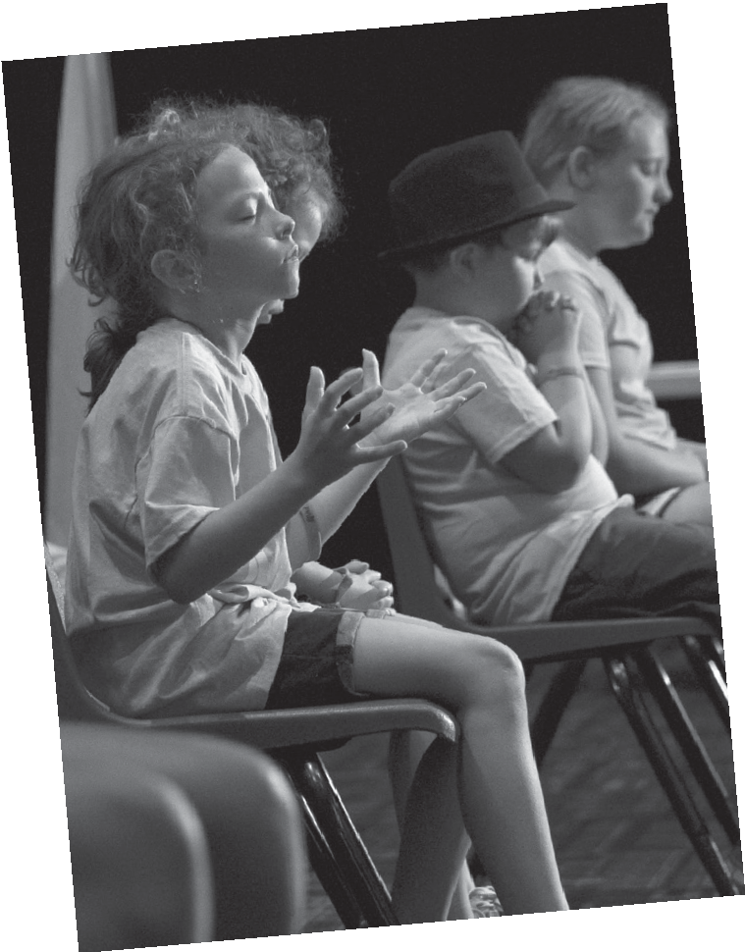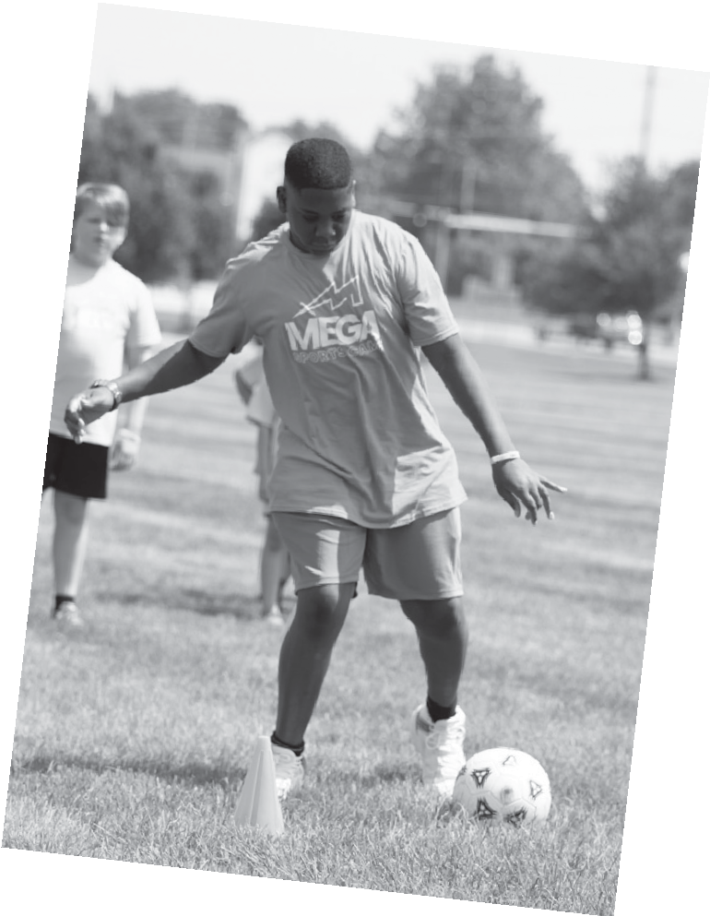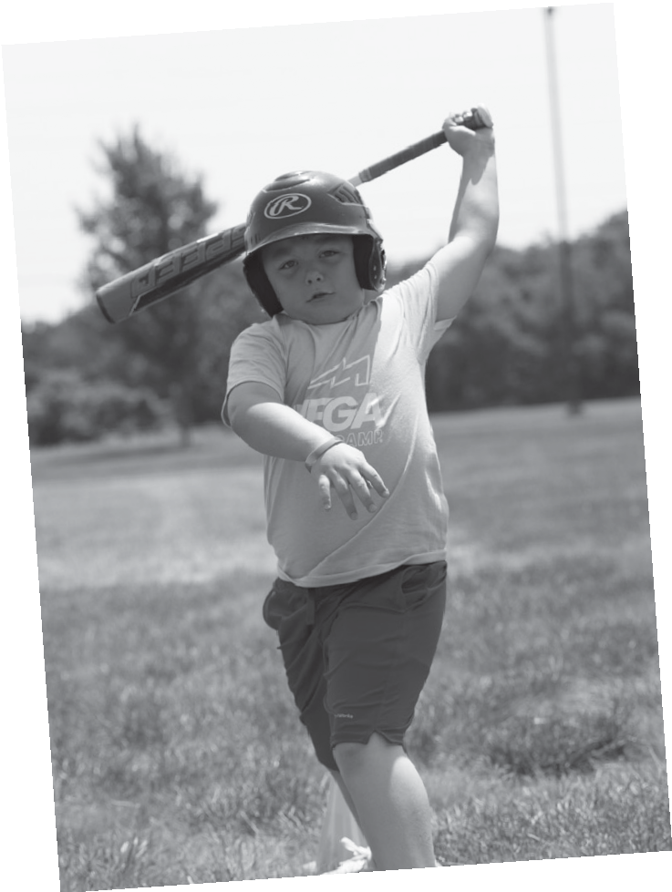DEAR PARENTS,
We’d love for your child to join us at our MEGA Sports Camp event! All the kids who attend will choose one of these sports to focus on:
Volleyball, Soccer, Basketball, Baseball, and Preschool
But that’s not all. Kids will also enjoy upbeat rallies filled with energetic music, fun sports stories, and Bible stories that will help them discover character traits to help them excel in sports and life. All this sports fun takes place at:
Bethesda Assembly of God,
2848 Brown Street Waxahachie TX
Starting on June 26th to June 30th, we’ll start off every day at 5:00 PM with Registration. After a fun-filled day, you’ll be able
to pick up your child at 8:30 PM.

Ready to sign up? Just complete the
Registration Form or call Sis. Vanesa 903-258-3327
or Bro. Primo 903-530-8315 or email RescueKids@bethesdawaxahachie.org. for more information.
Sincerely,
MEGA Sports Camp Director

P.S. Your child will get quality sports training, a T-shirt, snacks, bag, and supplies all for an affordable $20 per child or $40 per family/household. We’d like every child to come to our MEGA Sports Camp event, so ask about discounts if you have more than one child registering or if you’d like your child to be considered for tuition help or a scholarship. See you there!

© 2023 by Salubris Resources, 1445 N. Boonville Ave., Springfield, MO 65802. Permission to duplicate for individual camp use.

